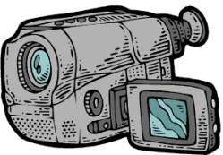
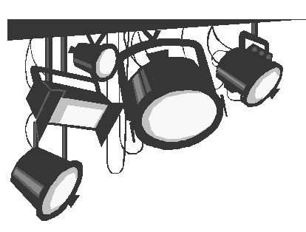

Video Production II
Studio Camera Set-up

It is essential to remember these six tasks each time you begin to set-up a camera for a studio shoot.

1Communication - Turn on and ensure that the intercom is working so there
is a clear communication path between you and the director.

2. Position- Move the camera into the director’s desired location for the
camera.

3. Iris - Work with the director to ensure that an appropriate
amount of light is moving through the camera’s iris.

4. White Balance- Have the subject hold up a white piece of paper. Zoom all
the way in on it and manually white balance the camera.

5. Focus - Zoom in on the subject’s eyes and rack the focus until the
picture is clear and sharp.

6. Compose - Ask the director for a Camera Shot Sheet. Find your first
camera shot and compose it.

